**Summary of Studies: FVB 9 Week Mice versus TAC 1 Week FVB 9 Week Mice**

Samples were taken from GSE56890. Treatments of Friend Leukemia Virus B (FVB) mice were compared to Transverse Aortic Constriction (TAC) treatments of FVB mice. Below (Figure 1) is an example of results gathered from the comparison program.

[Figure 1 Expression in gene GAPDH from analysis. Solid bars are FVB Female 9 week old mice, and striped bars are FVB Female mice that have hat the TAC treatment for 1 week out of the 9 weeks of their lives.]

**Methods**

Samples were downloaded from the study GSE56890 from NCBI. Datasets were processed through a Next Generation Sequencing Workflow and analyzed to observe differentially expressed genes (DEGs).

**Results for FVB 9 week Mice versus TAC 1 week FVB 9 week Mice**

Positive controls in this experiment showed NPPA, NPPB, and ACTB were positively differentially expressed between the two treatments. MYH7 (beta-myosin heavy chain), another positive control was not differentially expressed. Reciprocal controls SLC2A4 (GLUT4) and SLC2A1 (GLUT1) could not be evaluated since SLC2A1 was not differentially expressed in the analysis.

WWP1 was not differentially expressed in any of the four transcripts. As seen in the example above, two of the twelve transcripts for GAPDH were found to be differentially expressed. (ENSMUST00000118875, ENSMUST00000183272). Figure 2 below shows all differentially expressed genes for this study.

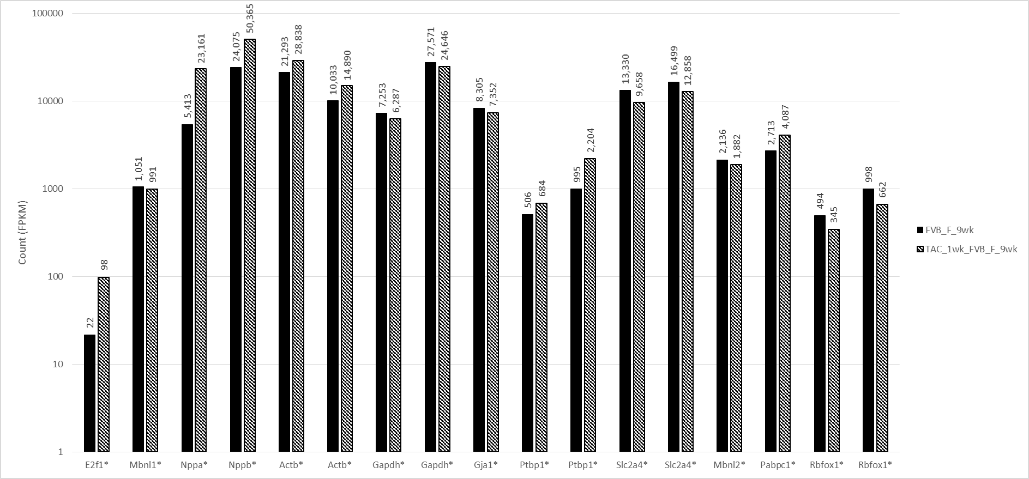

[Figure 2 - Differentially Expressed Genes for Study GSE56890.]